Supplementary information
Supplementary data include one Table to describe primers for MPYS exon genotyping and one Figure to show IRF3- or Traf2- association with SNPs
.
Supplementary Table
Supplementary Table 1: Primers used to amplify exons of human MPYS from genomic DNA.
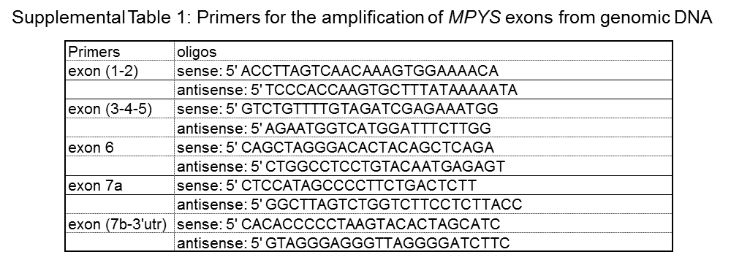
Supplementary Figure
Figure S1. HAQ variant has similar IRF3 association as WT-MPYS. a-b. 293MT cells were co-transfected with indicated plasmids. After 24 hrs, the cells are lysed in CHAPS buffer. Flag immunoprecipitation was performed. The blot was probed with anti-MPYS or anti-Flag Ab respectively.

