A Perception-based emotional contagion model in crowd emergent evacuation simulation

Zhen Liu ¹ , TingTing Liu ², Minhua Ma ³ , Hui-Huang Hsu ⁴, ZhongRui Ni ¹, YanJie Chai ¹

1 Faculty of Information Science and Technology, Ningbo University, Ningbo, 315211, China
2 College of Science and Technology, Ningbo University, Ningbo, 315211, China
3 School of Computing and Digital Technologies, Staffordshire University, Staffordshire, ST4 2DE, UK
4 College of Engineering, Tamkang University, Tamsui, 25137,Taiwan

Correspondence
Tingting Liu, College of Science and Technology, Ningbo University, China
Email: liutingting@nbu.edu.cn

Abstract
With the increasing number of emergencies, the crowd simulation technology has attracted wide attention in recent years. Existing emergencies have shown that individuals are easy to be influenced by other’s emotion during the evacuation. This will make it easier for people to aggregate together and increase security risks. Some of the existing evacuation models without considering emotion are therefore not suitable for describing crowd behaviors in emergencies. We propose a perception-based emotion contagion model and use multi-agent technology to simulate the crowd behaviors. Navigation points are introduced to guide the movement of the agents. Based on the proposed model, a prototype simulation system for crowd emotion contagion is developed. The comparative simulation experiments verify that the model can effectively deduct the evacuation time and crowd emotion contagion. The proposed model could be an assistant analysis method for crowd management in emergencies.

KEYWORDS
crowd simulation, emotion, emotion contagion, perception

INTRODUCTION

Public places have been more crowded with the progress of the global urbanization. Meanwhile, public safety and crisis management is facing unprecedented challenges with the increasing number of emergencies. In emergencies, overcrowded places become dangerous and would result in large numbers of casualties. It has important practical significance to simulate crowd behaviors in emergencies.
After analyzing real incidents of emergencies, we find that existing emergency plans always have problems to cope with changeable emergencies. In emergencies, people are easily to generate negative emotions and will spread their panics to others. The panic emotion will lead to irrational behaviors. Exploring the law of crowd evacuation behaviors will help us to develop scientific crowd management plan and reduce the emergent evacuation risk. However, it is not suitable to observe crowd behaviors from evacuation drills as those drills will be constrained by the space, cost or time and cannot be applied widely. With the development of the information technology, it is possible to carry out evacuation drills in the virtual world. The crowd simulation technology could be an assistive tool for developing emergency plans.
There are various models can be used to simulate crowd behaviors. However, most of these models simulate the movement of the crowd without fully consider people’s psychological and social features. With those models, we are difficult to describe authentic crowd evacuation behaviors in 3D virtual scenes. When those models are used in the commercial simulation software, they cannot deduce extreme behaviors in emergencies very well.
This paper proposes an agent-based emotion contagion model to visualize the crowd evacuations in emergencies. The social force model is used to compare with the proposed model. Experimental results showed that the proposed model has better performance in reproduce crowd behaviors and could be a new method for crowd simulation.

Comp Anim Virtual Worlds. 2018 wileyonlinelibrary.com/journal/cav

Section 2 reviews related work. Section 3 describes how an agent will perceive and response in the emergency. Section 4 proposes a navigation model for agent evacuation. Section 5 computes the emotion contagion. Section 6 is the experimental results, and section 7 summarizes our findings.

RELATED WORK

In crowded places, panic emotion will cause crowd disaster during the emergency evacuation. Understanding human behaviors and defining behavioral rules in emergency evacuation will be helpful to prevent the crowd disaster from occurring again. As it is almost impossible to conduct an experimental study of evacuation with human in panic condition, some researchers conducted experiment with social animal groups to explore pedestrians’ evacuation dynamics in panic scenarios [1]. However, results of animal experiments cannot be applied directly to the human system. Researchers tried to collect empirical data by videos [2], Shiwakoti selected rare video footage of panic escape at a shopping center during an Earthquake in China. The extracted data are then used to test a force-based crowd simulation model [3]. To provide better qualitative and quantitative data on human behaviors, Bernardini even built a large evacuation database of a wide number of videotapes concerning real incidents from all over the World [4].
A challenging problem in crowd simulation is how to generate the motion of autonomous agents based on real-life scenarios [5]. There are some typical approaches to simulate crowd dynamics. Among them, social force model (SFM) is a very classic one that has inspired lots of researchers [6]. To improve the performance of the SFM, some models modified the SFM by applying other rules to simulate high-density crowds [7]. In [8], a mobile grids was applied to the SFM.
In crowded environment, agents may collide with each other, push others, or afford forces form other agents or obstacles in the environment. Therefore, they may need to change their trajectories or behaviors to avoid upcoming collisions. Researchers have used RVO (Reciprocal Velocity Obstacle) for real-time multi-agent navigation [9] and proposed sets of rules for both collision avoidance and collision response [10]. To make agents become more intelligent, some researchers used theories of cognitive science to improved agents’ autonomous performance and enhanced their self-organization pattern [11]. The agent-based behavior modeling is the basis of the crowd simulation [12]. Kapadia et al. used the concept of affordances to describe the possible ways an agent would interact with its environment. each agent perceives the environment through a set of vector and scalar fields that are represented in the agent’s local space[13].Mei et al. described an agent-based egress simulation tool, SAFEgress, which is designed to incorporate human and social behaviors during evacuations. In SAFEgress, an agent can perceive the navigation objects in the virtual environment to guide their evacuation [14]. Huang et al. proposed a model that included smoke and noxious fumes into an evacuation process [15]. Cassol et al. designed a crowd simulation tool to automatically reproduce crowd behaviors during building egress [16].They also proposed a framework to identify optimal evacuation plans for specific spatial locations [17]. During the evacuation, agents will communicate with each other. Kullu et al. presented an approach to simulate communication between the agents [18]. Galea proposed a general approach to validate evacuation models [19].
In recent years, more and more researchers realized psychological factors are very important to simulate agents with believable behaviors. Kim et al. used stress model to simulate dynamic patterns of crowd behaviors [20]. They also tried to give an agent the possibility to perceive the situation according to its own characteristics and to adapt its behavior according to the situation [21]. Various theories about psychology and sociology are used to construct models for simulating pedestrian behaviors in a crowded space [22][23][24]. Wolinski et al. formulated parameter estimation as an optimization problem and proposed a general framework to solve the combinatorial optimization problem for all parameterized crowd simulation algorithms [25]. In those psychological factors, emotion is a crucial factor to describe people’s irrational behaviors in the emergency. It is necessary to introduce the theory of affective computing into crowd simulation. The famous OCC (Ortony, Clore, and Collins) emotional model has been proposed as early as 1998 [26]. Picard summarized previous researches on emotion and presented contents of affective computing [27]. In emergencies, individual will communicate with each other and will be influenced by others. The group decision will be affected by those mutual emotions [28]. Emotion contagion is a key factor for the crowd emotion. Hatfield et al. defined emotion contagion as the tendency to automatically mimic and synchronize with another person’s facial expressions, gestures, vocalizations, postures and movements and converge emotionally as a consequence [29]. While considering emotion contagion, we need to consider the absorption or amplification of emotions of others [30] and different crowd composition [31]. Durupınar et al. provide animators/designers with a tool to easily simulate the behavior of different crowd types. The proposed framework associates psychological components with individual agents comprising a crowd and yielded emergent behaviors in the crowd as a whole [32]. Tsai et al. examined computational models of emotion contagion by implementing Durupinar work and ESCAPES simulator [33]. Based on learning the OCEAN and emotion parameters from real videos, Basak et al. proposed a data-driven emotion contagion approach for crowd simulations [34].
In summary, although the research in crowd simulation technology has made great progress, the simulation method for crowd behavior under the emergency still needs further improvement. Real cases show that the crowd emotion contagion has a significant impact on the crowd evacuation. Mechanical models cannot describe the interaction between individuals. Using agent-based technology and psychological principles in the crowd simulation has become a new trend. Some of the existing emotion contagion models have not been thoroughly compared to other models. We still need a quantitative description of the relationship between the agent perception and the crowd emotion. Comprehensive considering of crowd's perception, emotion and evacuation behavior will help us simulate crowd evacuation behaviors accurately.

EMERGENCY PERCEPTION

Agent-based technology will be used to simulate crowd behaviors during the emergency evacuation. In our experiments, the smoke does not take into consideration.
Figure 1 shows how an agent perceives an incident and response to it in the proposed model. An agent will perceive the incident information through its sensor. Its emotion and behavior will change according to the perceived information. The emotion also will be affected by the emotion contagion. When such kind of change happened, its behavior will be affected. Behavior is performed by actions, which include navigation and collision detection. Without considering smell and touch, we set two sensory modalities for every agent: vision and audition. A circular area is used to represent the sensing area of vision and audition.
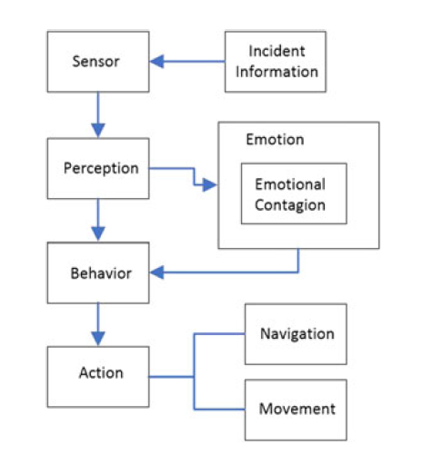
FIGURE 1 Emergency perception and response
An agent will have different perception processes for different emergencies. In an earthquake, all agents may perceive the incident at the same time. Then their states change from normal to evacuation. In a fire or a terrorist attack, agents may not perceive the incident at the same time. The agent, who is closest to the fire spot or the terrorist, will be the first one to perceive the incident with their visual perception. They may transmit the perceived information through yelling or shouting. Therefore, other agents, who have not seen the incident, can perceive the incident through their auditory sense. However, the scope of sound transmission won’t be very wide as there are many noises in the crowded place. The transmission of the information is a very complex process. We assume that incident information is transmitted at a certain speed.
For an emergency, we use a circular region with a radius of R_{ev} to represent the incident affected area. R_{ev} will increase at a rate of v_{ev} (m/s). During the evacuation, the incident information will be transmitted. We use a circular region with a radius of R_{in} to represent the range of the transmitted information. R_{in} will increase over time, at a rate of v_{in} (m/s). Let D_{p} be the minimum perceptual distance between an agent and the edge of an incident, F(x_{f},y_{f}) be the projection point of the center point of an incident and A(x_{a}, y_{a}) be the projection point of the center point of an agent on the two-dimensional plane, t be the occurrence time of the incident ( in seconds). D_{FA} be the distance between F and A on the two-dimensional plane. If D_{FA}<max{(R_{ev}+D_{p}+v_{ev}t),v_{in}t}, agent’s escaping behavior will be triggers out.

NAVIGATION MODEL FOR AGENT EVACUATION
During the evacuation, agents need to determine the evacuation routes and avoid obstacles according to the perceived information. While facing an emergency, people should make a rapid response. There is no time for them to analyze the overall situation. Therefore, navigation for an agent should be based on local information. Figure 2 shows the evacuation routes in an indoor environment (such as supermarket). The filled rectangular areas represent shelves, and the dotted boxes between shelves represent passable areas. There are some intersections of horizontal and vertical directions. These intersections are regarded as navigation points, which have same horizontal or vertical distances from their surrounding obstacles. The minimum distance between each shelf and passable area is the same.
In order to realize the motion navigation for an agent, the method of information annotation is adopted for every navigation point. Information about every navigation point’s spatial position and every adjacent point’s code is pre-recorded. During the evacuation, an agent will move from the current navigation point to an adjacent navigation point and keep on moving on the same side of the navigation points. Let P(x,y) be the current position of an agent, P_{na}(x_{na},y_{na}) be the next navigation point, and dir be the code of the motion (for four directions: up, down, left and right, dir equals to 1, 2, 3, 4 respectively). Let l_{x} and l_{y} be the length and width of the passable area between two shelves, P_{o}(x_{o},y_{o}) be the motion target and rand be a random number between 0 and 1.
From the surveillance videos of emergencies, it can be observed that an individuals’ movements cannot always be in a straight line. Therefore, we need to set a random amount in the equation to describe the offset of the agent's motion. The following equation can be used to navigate an agent along the vertical direction:

(1)
(2)
While navigating the agent along the horizontal direction, the following equation can be used:

(3)
(4)
Through passable area, agents can reach the exit. Every navigation point has a location navigation factor NL_{i}. Let D_{i} be the distance from the current navigation point to the exit along the navigation point. The value of D_{i} is the sum of the horizontal and vertical distances from the current navigation point to the exit point.
The location navigation factor can be expressed as the following equation:
(5)
If the distance from the agent to a navigation point is less than a certain boundary value, the agent can be considered as passing through the navigation point. the number of agents in each navigation point changes constantly. The navigation point, which has been passed by more agents who are familiar with the evacuation route, will be more likely to attract the agent who are unfamiliar with the evacuation route. We introduce a state navigation factor NA_{i}, it can be expressed as the following equation:

NA_{i}=PN_{i}/S (6)

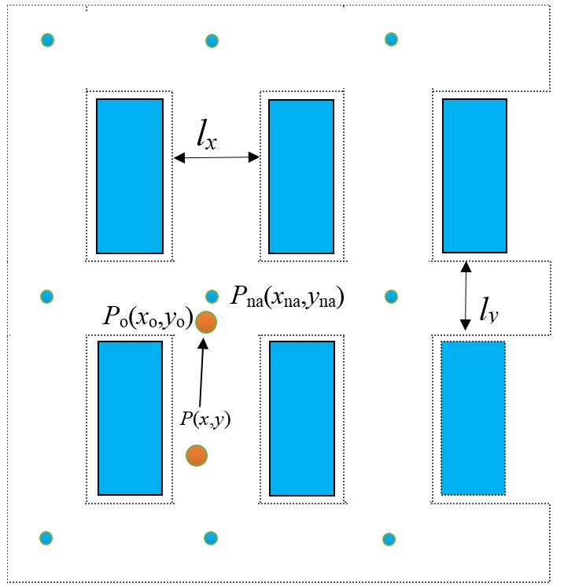
FIGURE 2 Indoor navigation for crowd

Where PN_{i} is the number of agents who are familiar with the evacuation route and passing through this navigation point, and S is the total number of the agents.
Agents can be divided into two types. One is familiar with the evacuation route and navigated by the location navigation factor. The other is unfamiliar with the evacuation route and will move toward the nearest navigation point that with the most passing agents.
We use RVO collision detection to detect upcoming collision between agents [9]. If a navigation point covered by a fire or passed by a terrorist, it will be marked as a forbidden point. If the front navigation point is a forbidden point, agent will change its direction and escape through other navigation points.
In the process of navigation, an agent should first judge the visibility of the surrounding navigation points, the connection between the agent and the navigation point will be checked. If the connection does not intersect with the obstacle, the navigation point is visible. From these visible navigation points, the agent will select the one that with the largest location or state navigation factor and move to it.

COMPUTING EMOTION CONTAGION
According to the real surveillance videos of emergencies [2][3], we can make some assumptions about crowd emotion contagion:
Assumption 1: Every individual has two states: normal state and evacuating state.
Assumption 2: Emotion will be triggered off in an emergency. When the intensity of the emotion exceeds a certain threshold, an individual will be in an emotional state and start to evacuate. During the evacuation, they will speed up and influence the surrounding people.
Assumption 3: Individual’s emotional state will be affected by the surrounding people. Assuming there is an emotional impact radius and emotion-affected area. The area is a circle, centered at the current position of the individual. Emotion contagion occurs when other individual enters into this area.
Assumption 4: There are two stages of the emotion contagion. During the first stage, some individuals are in the emotional state and can cause emotion changes of the surrounding individuals. Distant individuals will not be affected by those emotional individuals. During the second stage, panic emotions spread from local area to the whole crowd and cause a wide range of emotion contagion. The crowd will evacuate to the exit.
To simulate how the emergency will influence the emotion of an individual, we should first determine the emotional state of the agent after it perceives the danger, and then consider the emotion contagion between agents. Since the distance from the agent to the edge of the incident affected area is an important factor of emotion contagion, we use two parameters and to represent the boundary distance. is the nearest distance to the incident affected area and is the furthest distance that an agent can perceive the incident. Let e₀ be an agent's emotional intensity that affected by the incident, it can be calculated as follows:

(7)
As mentioned in assumption 2, an individual's emotions will be affected by surrounding individuals. Let R_{e} be the impact radius of the emotional affected area, N_{e} be the number of entered individuals, and em_{i} be the emotion value of the entered individual. The average emotion value M_{e} could be expressed by the following equation:

(8)
If e <M_{e}, an individual’s emotion value will be affected by the surrounding agents. Assuming A_{b} is the emotion absorption coefficient, w is an adjustment parameter，T_{e} is the emotion contagion interval, for every time interval T_{e}, an individual’s emotion value can be updated by the following equation:
(9)
Where A_{b} relates to individual’s personality and will affect the effectiveness of the emotion contagion. We use the OCEAN model to describe an individual’s personality. The proportions of different personality types will be set during initialization [24].
We use red color to represent the panic state. There are two emotion thresholds e_{t} and e_{l.} If ee_{t}, agent will turn red, which means it is in a panic state; if e_{t}>ee_{l}, agent will turn yellow, which means it is in the critical state; if e_{l}>e, agent remains the default color. While an agent in a panic state, it is also in the evacuating state as it has already perceived the emergent event.
An agent’s velocity v will be changed with the emotion value. Let v₀ be the initial velocity. It is adjusted by parameter K, which can be adjusted in the simulation program. v could be expressed as follows:

(10)

| EXPERIMENTS AND RESULTS

C# and Unity3D is used to develop a crowd simulation system. In this system, users can construct different scenarios, place obstacles, specify navigation points, exits (sizes and locations), and the source of the emergency (the place it occurs). The scene information will be saved in an XML file finally. The crowd simulation algorithm is implemented using C#. The position and emotion of the agent are recorded periodically and saved to a data file. The process of agent's emotion contagion and trajectory will be displayed in 2D/3D. Unity 3D is used to implement 3D rendering of the simulation data, and can visualize 3D crowd movement.

6.1 | Evacuation time in real video and the proposed model

To evaluate the effectiveness of the simulation, we compared the result of the simulation to a real surveillance video. Based on the surveillance video and news reports, the experiment reproduced the classroom’s size and layout proportionately. Figure 3(a) is the surveillance video of Mingshan High School in the April 20, 2013 Lushan earthquake, China [2]. Figure 3(b) is the crowd simulation with the proposed model. Considering people’s fastest evacuation speed will exceed 3m/s, which can be estimated from the surveillance video, an agent’s maximum expected speed in this experiment is set to 3 m/s. Figure 4 is the comparison result of the real video and the simulation. As shown in figure 4, the simulation data and the real data are similar in the evacuation time but are different in representing the process of the evacuation. The difference is caused by the setting of the experiment. For simplicity, in this experiment，we set the parameters of all agents to be the same. However, each student in the real incident is different. Some students can respond quickly to the earthquake and some may not. More importantly, students can run sideways in the classroom aisles to overtake others. This cannot be reproduced in the simulation as agents in the simulation are cylindrical. They cannot go sideways to overtake others in the aisles. In addition, the simulation also cannot completely reproduce the evacuation order for a particular agent. Considering the simulation should aim at the overall situation of the evacuation but not the individual in the evacuation, the proposed model is effective as the experimental results are consisted with the overall behavior of the crowd and the total evacuation time in the real surveillance video.



FIGURE 3 (a) A screenshot of real surveillance video

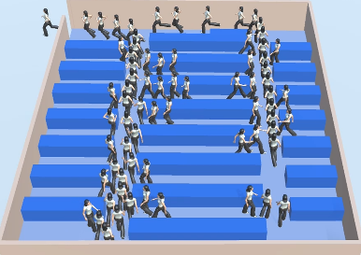

FIGURE 3 (b) A screenshot of simulation

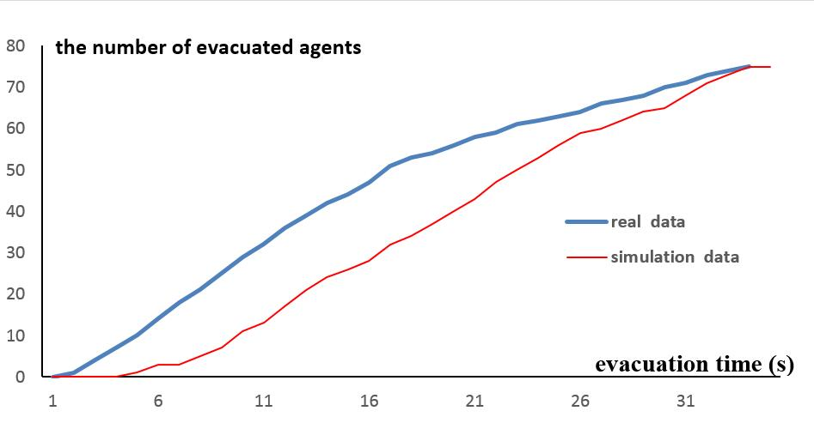
FIGURE 4 The comparison of real video and the proposed model

6.2 | Comparative analysis

We present the results of crowd evacuation simulation using social force model (SFM), the constructed infection model and the proposed model, respectively.
In the experiment, the crowd will evacuate from a supermarket when they perceive the fire. The supermarket is rectangular, with a length of 120m and a width of 60m, while shelves are also rectangular with a length of 10m and a width of 3m. Each accessible area is at a minimum distance of 0.4 m from the edge of the shelf. The expansion speed of fire-affected area is 0.1m/s, the information transmission speed is 1m/s. is 0.5m while is 10m. An agent will be affected by the emotions of others within a radius R_{e}=10m. Each agent with the radius of 0.4m and initial average velocity 1.5m/s. With the adjustment parameter K=2, the velocity will gradually increase with the emotion contagion. We take e_{t} =0.5 and e_{l} =0.45. The maximum speed is 4.5m/s. based on the OCEAN model [24], there are five different personalities among the crowd. In the initial state, the proportions of these personalities are as follows: Type-O: 15%; Type-C: 20%; Type-E: 20%; Type-A: 20% and Type-N: 25%. When the personality is type N, the value of A_{b} is 1; when the personality is type A, O and E, the value of A_{b} is 0.8; when the personality is type C, the value of A_{b} is 0.6. ,and w is 6.Since fires are spread from the local, not all people can sense the fire from the very beginning.
In order to compare the proposed perception-based emotion contagion model, a perception-independent emotion contagion method is constructed to generate more rapid emotion contagion. This method is learned from Durupinar et al’s emotion contagion approach [28] and is called infection model here. With this model, all agents are randomly assigned a [0,1] normalized emotional value on initialization. The expectation is 0.1 and the variance is 0.01. While calculating the average emotional value M_{e} of others, agents that within 120 degrees of the current agent's view range and 10 meters distance will be selected as the influential agents. If the current agent's emotional value e<M_{e}, the emotion contagion will be triggered. The equation (9) can be used to update the current emotion. While using this infection model to describe emotion contagion in a supermarket fire, it would be more suitable for the contagion that people get fire news from the broadcast. Because the speed of the emotion contagion in this circumstance is faster than the speed of emotion contagion that caused by a certain agent.
The animation screenshot at the 40th second is selected to observe the simulation results under different crowd conditions.
In Figure 5, the red area on the left represents the spreading fire and the yellow area represents the transmission area of the fire information. The red agents represent agents that in the emotionally infected states and the yellow ones represent the agents in the critical states of infection. In the experiment, the speed of the emotion contagion is faster than the speed of the fire information transmission. The agent who perceives the fire or affected by the panic emotion will enter its evacuation state and run with the evacuation crowd.
In Figure 6, all agents are N-type. They are very sensitive. The rate of the emotion contagion will be increased. In Figure 7, 40% of the agents are unfamiliar with evacuation routes, they are likely to gather in local areas, this is dangerous and will increase security risks.
Figure 8 is the crowd evacuation simulation based on the constructed infection model. It shows that the agents infected by emotions have been distributed all over the supermarket from the very beginning, which is not in accordance with the characteristics of the fire. Figure 9 is the crowd evacuation simulation based on the SFM. It shows that the agent’s evacuation state is only influenced by the fire information. The emotion contagion is not considered in this model.
Figure 10 is the trajectories of the evacuation crowd that simulated by the proposed model. It can be seen that the agents near the source of fire (on the left) will start their evacuation earlier than others, and they will try to avoid the shelves during the evacuation. This is consistent with the results that observed in the real case. Figure 11 is the trajectories of the evacuation crowd that simulated by the SFM. It can be seen that the agents escape to the exit straightly, some agents move close to shelves, which is rare in the real world.
Figure 12 shows the relationship between the number of the evacuated agents and the time. It shows that the SFM has the longest evacuation time as it does not consider the information connection between agents. While the infection model has the shortest evacuation time as it does not consider the characteristics of the perception. With the infection model, the evacuation does not start from the place that near the emergent events but start from random places all over the supermarket.
Figure 13 is the comparison of the population near the exit for the three models. The measured area is rectangular, with the width of 11.5 m and height of 20 m. The exit is centered at the top of this rectangular area. The figure shows that with the infection model, people will gather at the exit in the early stage of the evacuation, while with the SFM, the congestion occurs later. This shows that the emotional congestion can improve the efficiency of the evacuation. If the emotion spreads too fast, it may exacerbate the safety risk near the exit.
Based on the proposed model, Figure 14 compares the evacuation efficiencies at different exit widths. The result shows that a smaller exit width will reduce the crowd's evacuation rate. Congestions are more likely to occur near the exit and the safety risk will increase.
We also used the proposed model to analyze the effect of familiarity with the evacuation routes on the congestion at the exit. For agents that are not familiar with evacuation routes, status navigation factors can be used to provide navigation information. In many real incidents, people who are not familiar with evacuation routes may herd together. To represent the herding phenomenon, the numerator of the state navigation factor can be set as the number of agents passing a certain navigation point (equation 6). In this circumstance, agents who are unfamiliar with the evacuation route can easily cause aggregation and delay the evacuation time. Figure 15 shows that the more individuals in the crowd are familiar with the evacuation route, the faster the crowd can evacuate.

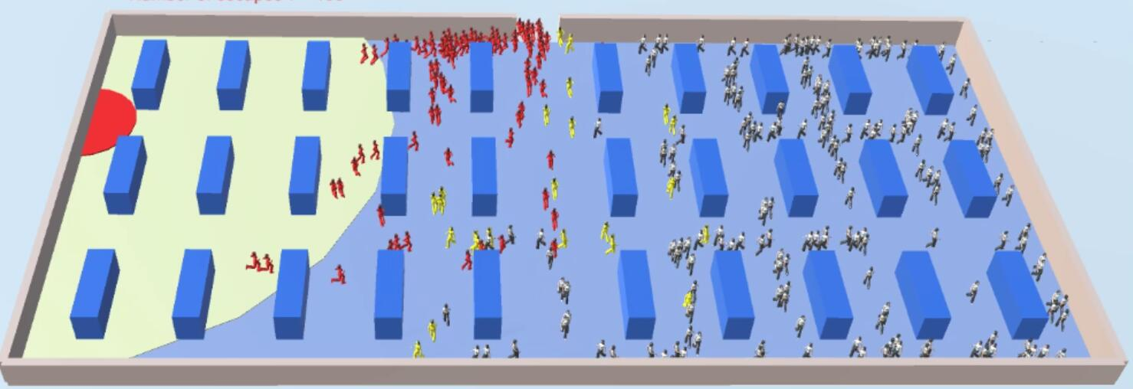

FIGURE 5 All agents are familiar with evacuation routes (proposed model)

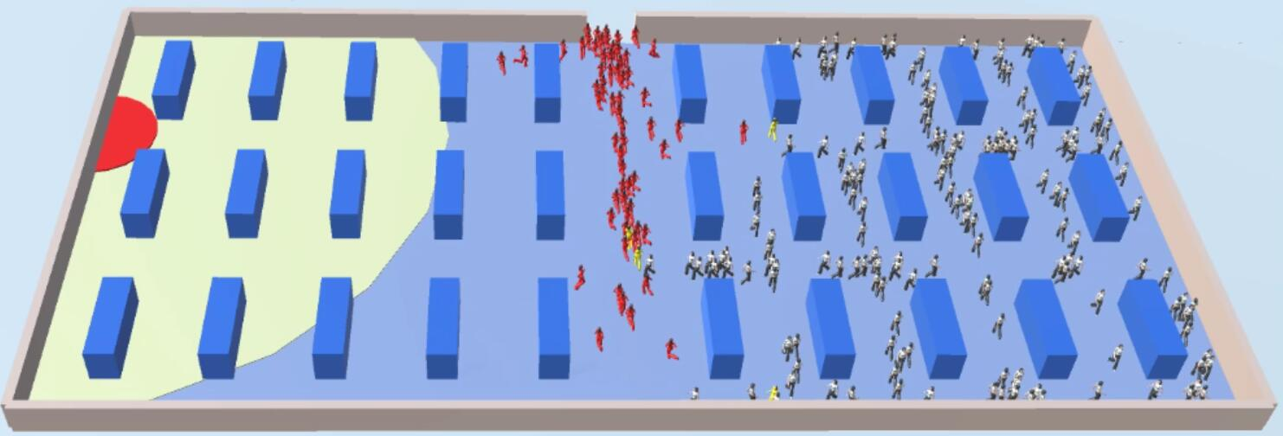

FIGURE 6 All agents are N-type. Parameters are the same as Figure 5 (proposed model)

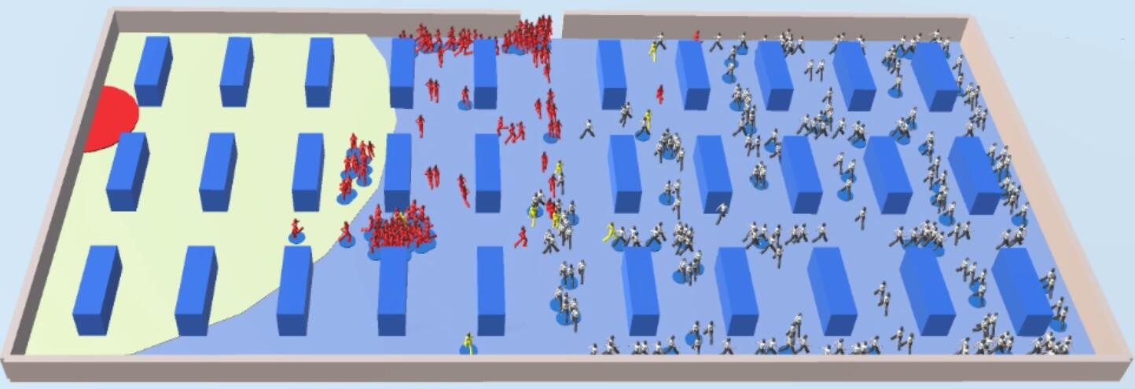

FIGURE 7 40% of the agents are unfamiliar with the evacuation routes. Parameters are the same as Figure 5 (proposed model）

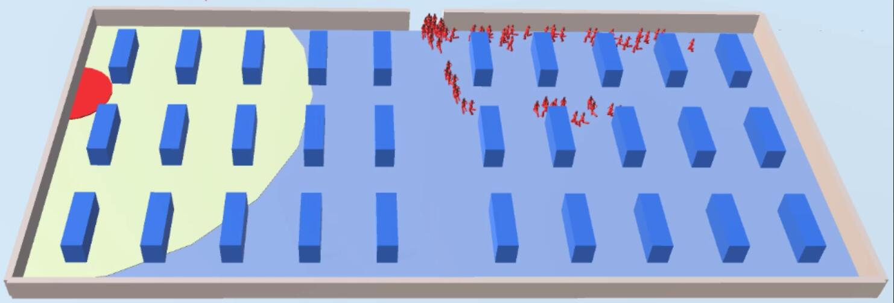
FIGURE 8 The crowd evacuation simulation based on the constructed infection model

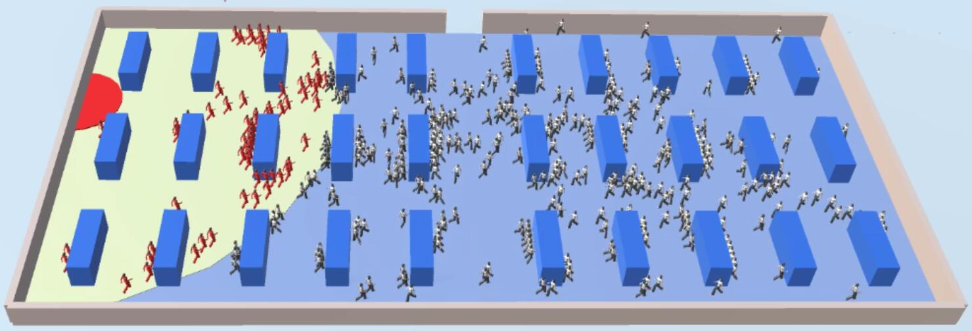
FIGURE 9 The crowd evacuation simulation based on the SFM

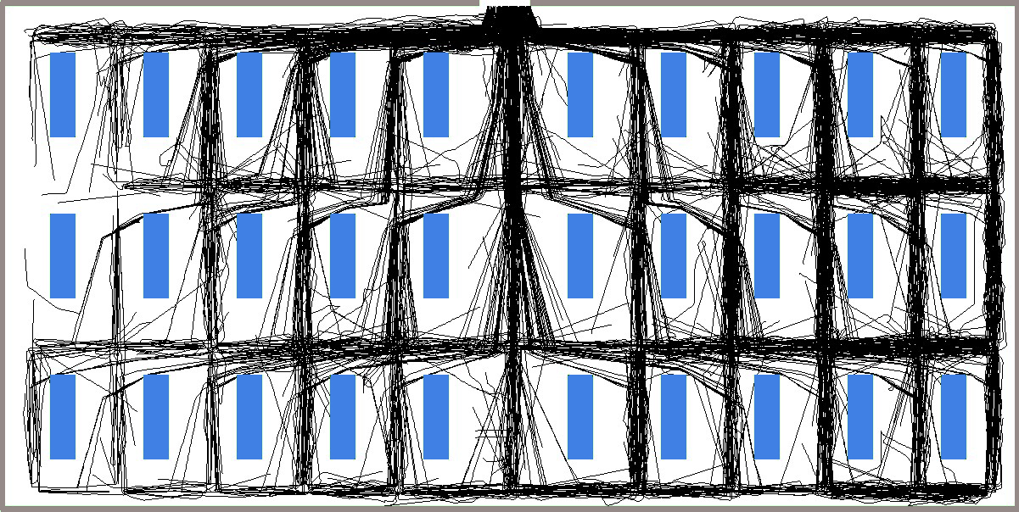
FIGURE 10 The trajectories (black lines) of the evacuation crowd simulated by the proposed model (generate from Figure 5)

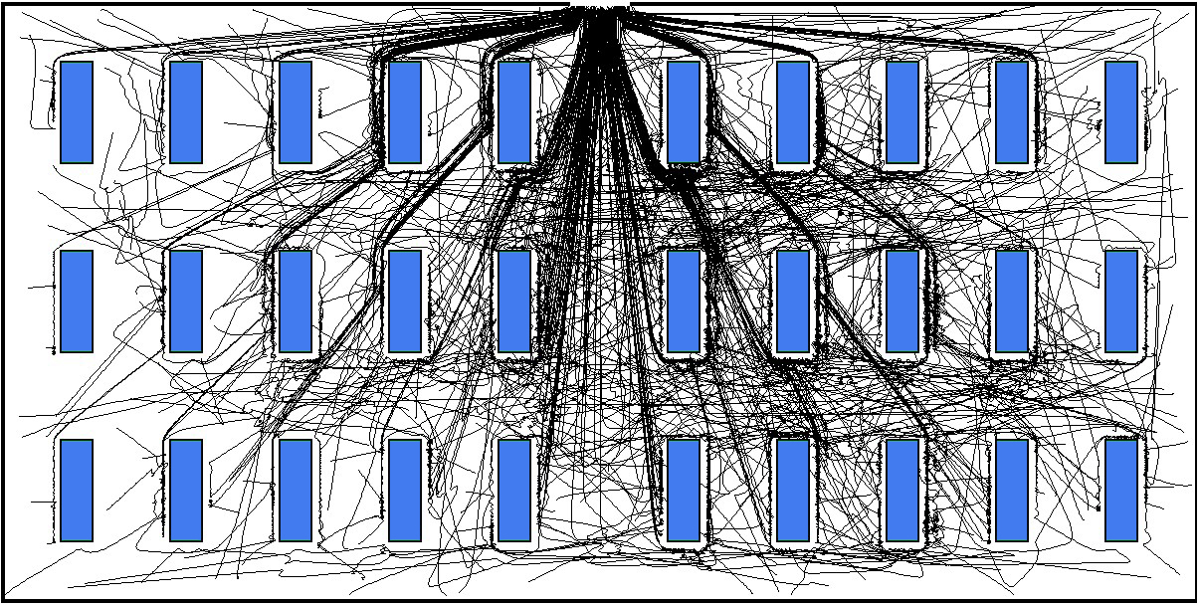
FIGURE 11 The trajectories (black lines) of the evacuation crowd simulated by the SFM (generate from Figure 9）

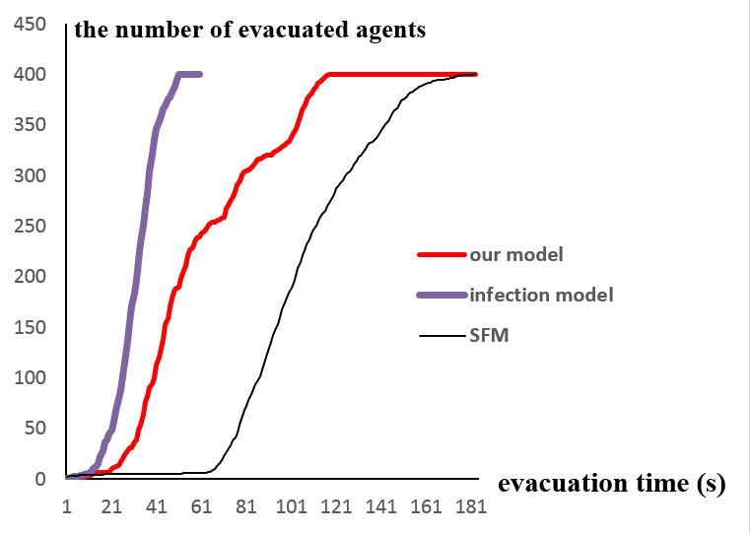

FIGURE 12 The relationship between the number of evacuated agents and the evacuation time

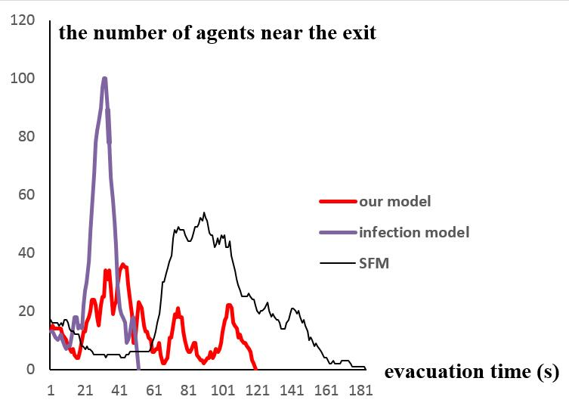
FIGURE 13 The comparison of the agents near the exit for the three models

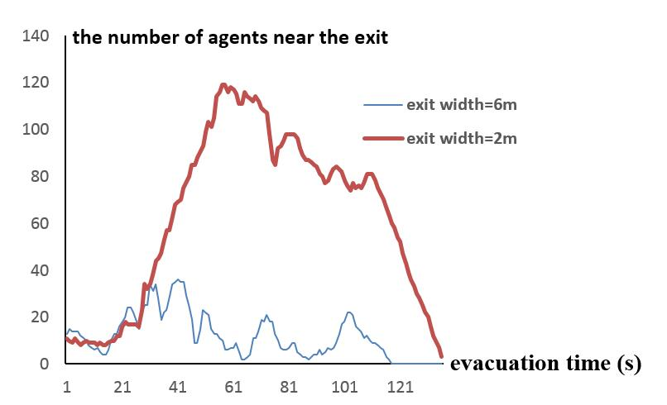
FIGURE 14 The number of agents near the exit with different exit widths

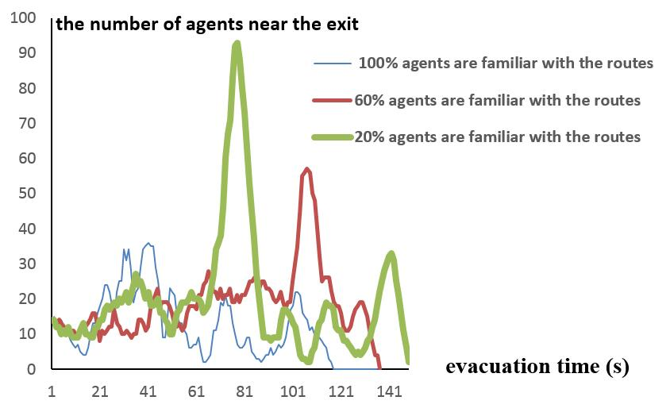

FIGURE 15 With different percentages of agents who are familiar with the routes

Qualitatively speaking, the proposed model provides a visual method to describe the emotion contagion. It can visualize the panic crowd evacuations in emergencies. The experimental results are consistent with real incidents. For example, in experiment, fast emotion contagion or people unfamiliar with evacuation routes may cause local congestion. This is consistent with the crowded trampling near the exit in many real incidents.
Quantitatively speaking, we use some parameters in our model. In order to obtain more accurate parameter values to reproduce real incidents, we have made detailed observations on many surveillance videos. The experimental results show that the proposed model is effective in reproducing evacuation time. Meanwhile, the quantitative comparison with the social force model shows that the proposed model is more suitable for deducing crowd behavior in emergencies.

7 CONCLUSIONS

We use an agent-based method to simulate evacuation process, construct the navigation points and the navigation factors to realize the navigation of the agents. The navigation method can well describe the random factors in the evacuation. According to the real case, the paper makes some assumptions about the emotion contagion and puts forward the equations of the emotion contagion. Finally, the simulation software is developed. Some experiments are carried out to simulate the crowd evacuation in the classroom and supermarket environment to verify the effectiveness of the proposed model. In the supermarket fire experiment, the proposed model is compared to other models. The experimental results show that the proposed model is coincident with the real evacuation situation.
The results of this study show that the emotion contagion has a great impact on the behavior of the crowd evacuation. The moderate emotion contagion can disseminate the panic emotion in the crowd. It enables the other agents to perceive the emergency and start to evacuate in time. However, too much emotion contagion will lead to congestion at the exit and increase the risk of the exit. Therefore, properly control the emotion contagion can help people to evacuate safely and can reduce the risk of the exit.
The simulation about the crowd in emergencies is still a challenging topic. Emotion comes from perception, which includes not only vision and hearing but also smell and touch. For example, in a smoke-filled environment, the emotion contagion model is related to the hearing, touch, and smell. We will improve the proposed emotion contagion model in our future work.

REFERENCES
- Lin P, Ma J, Liu T, Ran T, Si Y, Li T. An experimental study of the “faster-is-slower” effect using mice under panic. Physica A: Statistical Mechanics and its Applications. 2016; 452: 157-166.
- Gu Z, Liu Z, Shiwakoti N, Yang M. Video-based analysis of school students' emergency evacuation behavior in earthquakes. International Journal of Disaster Risk Reduction. 2016; 18: 1-11.
- Shiwakoti N. Understanding differences in emergency escape and experimental pedestrian crowd egress through quantitative comparison. International Journal of Disaster Risk Reduction. 2016; 20:129-137.
- Bernardini G, Quagliarini E, D'Orazio M. Towards creating a combined database for earthquake pedestrians' evacuation models. Safety Science. 2016; 82: 77-94.
- Daniel, T, Raupp, MS: Crowd Simulation. Springer-Verlag London:Springer London Heidelberg New York Dordrecht; 2013.
- Helbing D, Molnár P. Social force model for pedestrian dynamics. Physical Review E. 1995; 51: 4282-4286.
- Pelechano N, Allbeck JM, Badler NI. Controlling individual agents in high-density crowd simulation. Proceedings of 7th ACM SIGGRAPH/Eurographics Symposium on Computer Animation, SCA 2007; San Diego, USA, 2007.
- Saboia P, Goldenstein S. Crowd simulation: applying mobile grids to the social force model. The Visual Computer. 2012; 28: 1039-1048.
- Van Berg JD, Lin M, Manocha D. Reciprocal velocity obstacles for real-time multi-agent navigation. Proceedings of IEEE International Conference on Robotics and Automation; Pasadena, CA, USA, 2008. p.1928-1935.
- Xiong M, Lees M, Cai W, Zhou S, Low MYH. Analysis of an efficient rule-based motion planning system for simulating human crowds. Visual Computer. 2010; 26: 367-383.
- Ondrej J, Pettre J, Olivier AH, Donikian S. A synthetic-vision based steering approach for crowd simulation. Proceedings of ACM SIGGRAPH 2010 papers; Los Angeles, California, 2010. p.1-9.
- Luo L, Zhou S, Cai W, Low MYH, Tian F, Wang Y, Xiao X, Chen D. Agent-based human behavior modeling for crowd simulation. Computer Animation and Virtual Worlds. 2008; 19: 271-281.
- Kapadia M, Singh S, Hewlett W, Faloutsos P. Egocentric affordance fields in pedestrian steering.Proceedings of the 2009 symposium on Interactive 3D graphics and games; Boston,USA, 2009. p. 215-223.
- Chu ML, Parigi P, Law KH, Latombe JC. Simulating individual, group, and crowd behaviors in building egress. SIMULATION. 2015; 91: 825-845.
- Huang P, Kider JT, Sunshine-Hill B, McCaffrey JB, Rios DV, Badler NI. Real-Time Evacuation Simulation in Mine Interior Model of Smoke and Action. Proceedings of Computer Animation and Social Agents 2010 (CASA); Saint-Malo, France, 2010. p. 312-317.
- Cassol VJ, Testa ES, Jung CR, Usman M, Faloutsos P, Berseth G, Kapadia M, Badler NI, Musse SR. Evaluating and Optimizing Evacuation Plans for Crowd Egress. IEEE Computer Graphics and Applications. 2017;37(4): 60-71,.
- Cassol V, Oliveira J, Musse SR, Badler N. Analyzing egress accuracy through the study of virtual and real crowds. Proceedings of 2016 IEEE Virtual Humans and Crowds for Immersive Environments; Greenville, SC, USA , 2016. p. 1-6.
- Kullu K, Güdükbay U, Manocha D. ACMICS. an agent communication model for interacting crowd simulation. Autonomous Agents and Multi-Agent Systems. 2017; 31(6): 1403-1423.
- Galea ER. A general approach to validating evacuation models with an application to EXODUS. Journal of Fire Sciences. 1998; 16( 6): 414-436.
- Kim S, Guy SJ, Manocha D, Lin MC. Interactive simulation of dynamic crowd behaviors using general adaptation syndrome theory. Proceedings of ACM SIGGRAPH Symposium on Interactive 3D Graphics and Games; Costa Mesa, CA, USA, 2015. p. 24-34.
- Sakuma T, Mukai T, Kuriyama S. Psychological model for animating crowded pedestrians. Computer Animation and Virtual Worlds. 2005; 16: 343-351.
- Fridman N, Kaminka G. Modeling pedestrian crowd behavior based on a cognitive model of social comparison theory. Computational and Mathematical Organization Theory. 2010; 16: 348-372.
- Ricks B, Egbert P. More realistic, flexible, and expressive social crowds using transactional analysis. The Visual Computer. 2012; 28: 889-898.
- Durupinar F, Pelechano N, Allbeck J, Güdükbay U, Badler NI. How the ocean personality model affects the perception of crowds. IEEE Computer Graphics and Applications. 2011; 31: 22-31.
- Wolinski D, Guy SJ, Olivier AH, Lin M, Manocha D, Pettré J. Parameter estimation and comparative evaluation of crowd simulations. Computer Graphics Forum, 2014; 33(2): 303-312.
- Ortony, A, Clore, GL, Collins, A. The cognitive structure of emotions. New York: Cambridge University Press; 1988.
- Picard, RW: Affective Computing. London: MIT Press; 1997.
- Bosse T, Hoogendoorn M, Klein MA, Treur J, van der Wal CN, van Wissen A. Modelling collective decision making in groups and crowds: Integrating social contagion and interacting emotions, beliefs and intentions. Autonomous Agents and Multi-Agent Systems. 2013; 27: 52-84.
- Hatfield, E, Cacioppo, JT, Rapson, RL. Emotion contagion. Cambridge: Cambridge Univ. Press; 1994.
- Bosse T, Duell R, Memon, ZA, Treur J, van der Wal CN. Agent-Based Modeling of Emotion Contagion in Groups. Cognitive Computation. 2015; 7: 111-136.
- Aydt H, Lees M, Luo L, Cai W, Low MYH, Kadirvelen SK. A computational model of emotions for agent-based crowds in serious games. Proceedings of 2011 IEEE/WIC/ACM International Conference on Intelligent Agent Technology; Lyon, France, 2011. p.72-80.
- Durupinar F, Gudukbay U, Aman A, Badler NI. Psychological Parameters for Crowd Simulation: From Audiences to Mobs. IEEE Transactions on Visualization and Computer Graphics. 2016; 22: 2145-2159.
- Tsai J, Bowring E, Marsella S, Tambe M. Empirical evaluation of computational fear contagion models in crowd dispersions. Autonomous Agents and Multi-Agent Systems. 2013; 27(2): 200-217.
- Başak AE, Güdükbay U, Durupınar F. Using real life incidents for realistic virtual crowds with data-driven emotion contagion. Computers & Graphics. 2018.

